

AQUADUCTOR ULTRAVIOLET WATER   
PURIFICATION CONTROLLER

USER INSTRUCTIONS

# Introduction

The Aquaductor Ultraviolet Water Purification Controller is designed to automatically provide safe, sanitised and potable water for you and your family.

Aquaductor automatically takes untreated water from your storage tank and treats it, to ensure that you have a steady supply of clean water. No manual intervention is needed – the controller will function by itself and notify you via an alarm if any problems occur.

These user instructions will help you get the best out of your Aquaductor system and allow you to use it safely, and we recommend you read through them fully!

Contents

Introduction 2

Contents 3

Safety Information 4

Technical Specifications 5

Components and Accessories 6

Installation & Commissioning 7

Installing Aquaductor 8

Commissioning Aquaductor 12

Cleaning and Maintaining Aquaductor 13

Operating Aquaductor 14

System Layout 14

Operational Flowchart 15

System Operation 15

System Inputs & Interrupts 18

Fault Indication 20

Troubleshooting 22

Warranty 24

Maintenance 24

Returning Aquaductor Controller for repair 24

WEEE Regulations 24

# Safety Information

* Please inspect your Aquaductor system and any accessories for damage when you receive it. If there is any damage, please do not use the system and contact your supplier or Support for assistance.
* Do not operate the system if the leads for controller power, pump or UVC tube show any signs of damage or wear.
* When maintaining or cleaning your Aquaductor system, please ensure that it is fully disconnected from the mains supply beforehand. We recommend removing the plug from the socket to ensure complete electrical disconnection.
* Aquaductor will automatically carry out current consumption tests on the supplied UVC tube during each treatment cycle. If an error occurs, for example if it believes the UVC tube is blown, an alarm will sound and the failure condition will be noted. Please contact your supplier or Support for advice.
* The automatic tests Aquaductor carries out are for your safety. Please do not attempt to bypass or workaround any tests, or manually run the Pump and UVC tube. This may cause untreated water to enter your treated water tank, which may cause you serious harm/illness or death.
* **The AQUADUCTOR CONTROLLER MUST be used with a residual current device, RCD/GFCI/RCBO device. Ensure that you test the residual current device after installation.**
* Aquaductor does not contain any user serviceable parts and should not be disassembled or repairs attempted. Please contact your supplier or Support for any assistance required.
* **DO NOT USE THIS PRODUCT AS AN ISOLATION DEVICE, TO ISOLATE PUMP, UVC TUBE, THEIR POWER SUPPLIES OR ANY OTHER EQUIPMENT. FOR COMPLETE ISOLATION YOU MUST DISCONNECT THE AQUADUCTOR CONTROLLER FROM MAINS POWER.**

# Technical Specifications

| **Feature** | AQUADUCTOR CONTOLLER |
| --- | --- |
| **Product Dimensions** | 200mm x 90mm x 62mm (including mount) |
| **Power Supply Input** | 120Vac, 60Hz, 3A (including power to UVC & pump) |
| **Fuses** | Two (live and neutral) 3A, 32x5mm quick blow. |
| **UVC Tube** | 16W @ 120Vac/60Hz (0.13A) |
| **Pump** | 40W @ 120Vac/60Hz (0.33A) |
| **Maximum switched load** | 3A (combined pump and UVC current) |
| **Product Weight (unpackaged)** | 400g |
| **Control Unit Enclosure** | Sealed to IP66 |
| **Audible / visible fault alarms** | YES |
| **Silence Alarm Button** | YES |
| **Override Control Button** | YES |
| **Microprocessor Control** | YES |
| **Controller position** | Wall mountable enclosure |
| **Ergonomic Design** | YES |
| **Limited Lifetime Warranty** | YES |
| **Product Compliance** | CE and LVD Compliant |
| **Country of Manufacture** | Northern Ireland/United Kingdom |



# Components and Accessories

Your Aquaductor system will come shipped with the following components. When you unpack please ensure you check everything is there, and if any parts are missing please contact your supplier or Support immediately.

1. 1 x Aquaductor wall-mountable controller.
2. 3 x hard-wired mains leads via cable glands for Controller Power Input (x1), Pump Power Output (x1) and UVC Tube Power Output (x1).
3. Connections for float level input switches for Source Tank S, Treated Tank T1 Low Sensor, Treated Tank T2 High Sensor.
4. 1 x User Instructions (detailed).

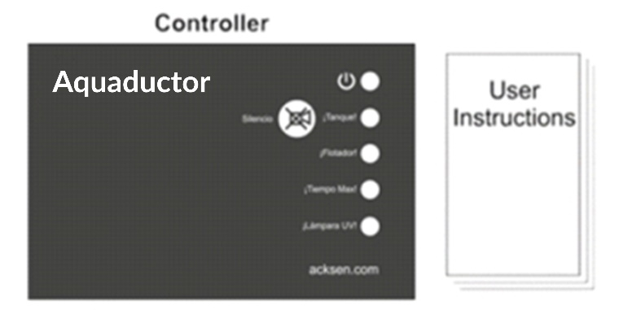

# Installation & Commissioning

**Aquaductor should be connected to an electric outlet suitable for the total electrical load. The supply MUST be protected by an RCD/GFCI/RCBO device, for your safety – please test the RCD/GFCI/RCBO device after installation.**

**IF YOU DO NOT UNDERSTAND THE ABOVE STATEMENT, PLEASE CONSULT A LOCAL EXPERT.**

Thanks to our automatic control system, using Aquaductor is simple. However, there is a small amount of installation and commissioning work which needs to be carried out on the system to start with.

## Installing Aquaductor

Below is an overview of the Aquaductor treatment system, and how each of the elements are connected together both from the water treatment side, and electrically back to the controller.

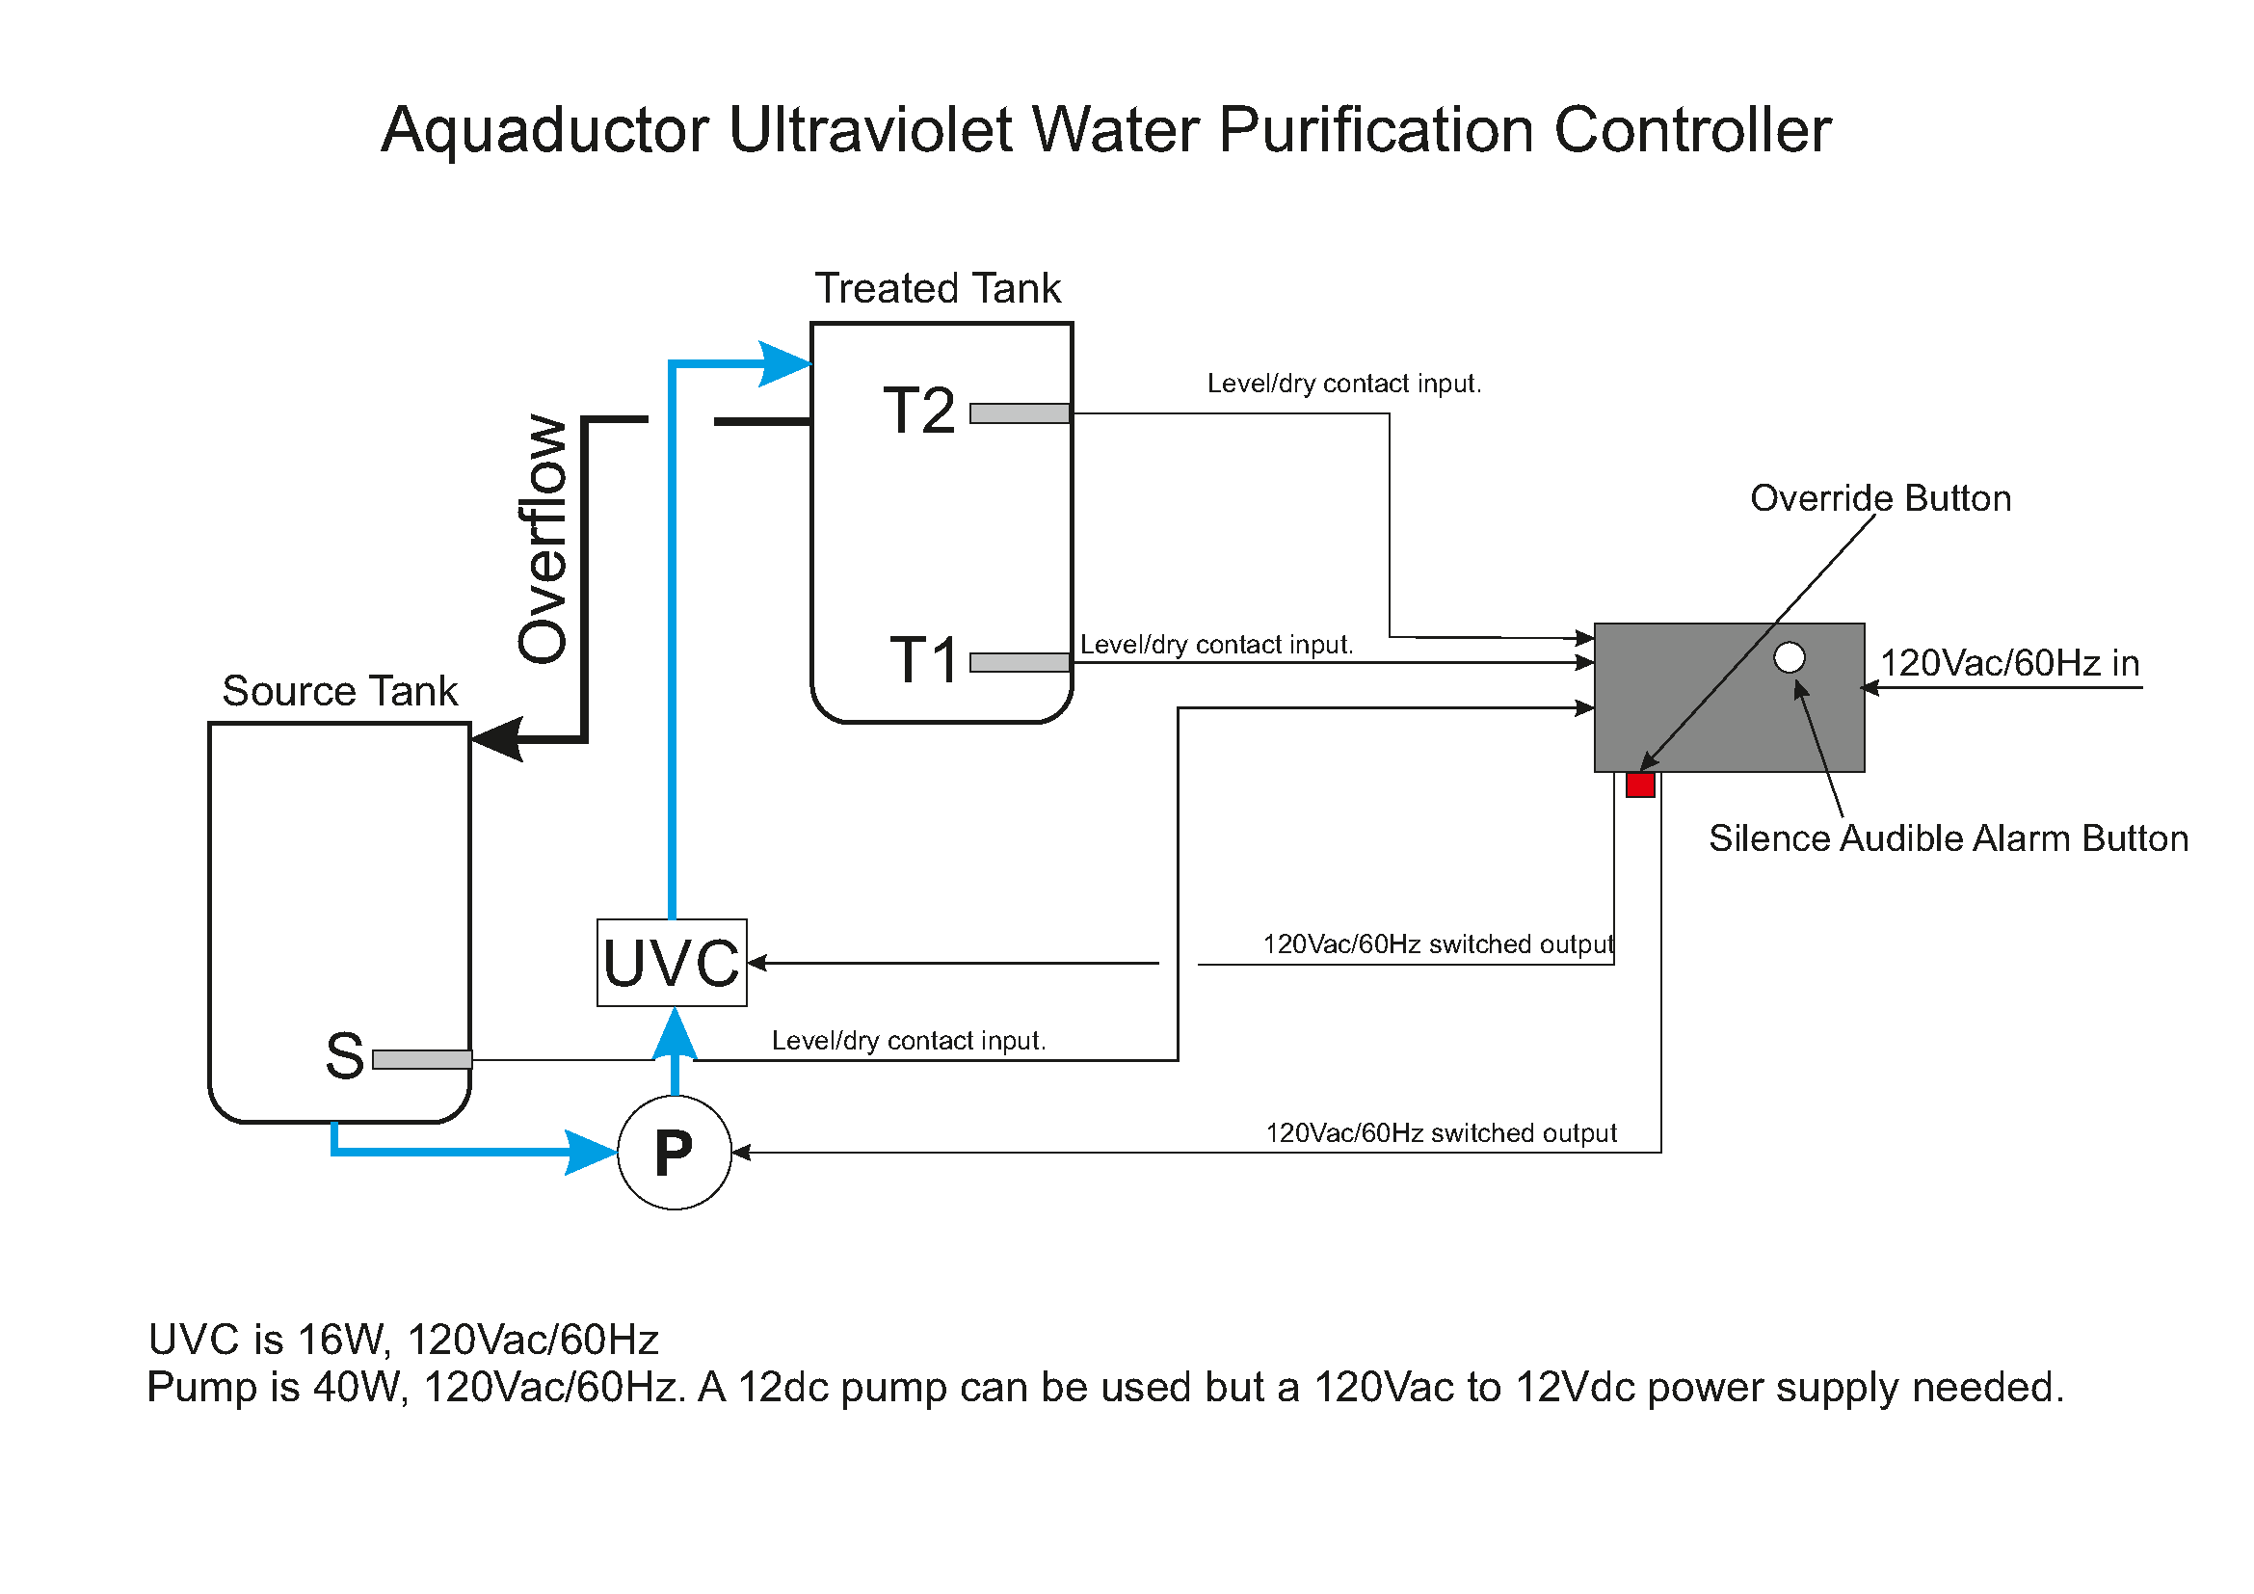

Your Aquaductor controller comes with wall mounting attachments. Please locate a suitable place to locate the controller, and permanently mount it to that position. We recommend you reference the suggested layout below when determining where to site your controller.

Please also ensure that you have set the correct runtime jumper setting on the controller board for the system you intend to deploy the controller with – either OPEN for 100 minutes max. pump runtime or CLOSED for 60 minutes max. pump runtime.

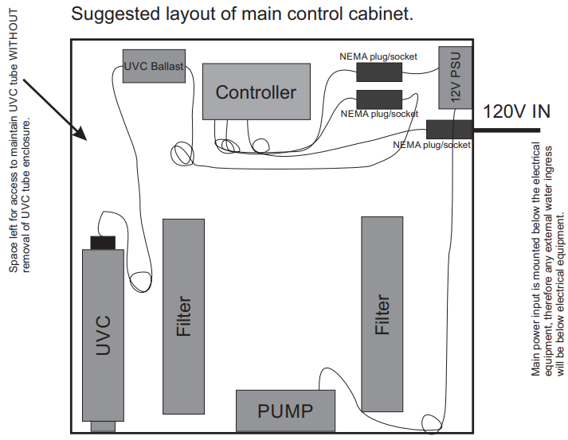

After this has been attached, you can begin to wire in the other necessary connections:

* 1 x Power Supply for Controller
* 1 x Power Output to Water Pump (Bomba)
* 1 x Power Output to UVC Tube (Lampara UVC)
* S, T1 & T2 Float Level Switches (dry contact input, open low level, closed high level)

NOTE: to turn off the controller, remove power from the system.

Before installing the floats in the tanks, please ensure you know and understand how the orientation of the floats (low-high positions) relates to the open-closed output of the switch. The controller assumes that a low water level float position will be an open on the float contacts and a high-water level will move the float to a closed switch contact position.

**Connect the float inputs to the controller, set each float flat and ensure each is in the high-level position. Label each float lead (S, T1, T2).**

Please take care to ensure that the Float Level Switches are connected to the controller connectors in the order S, T1, T2 – and that they are sited correctly on the water tanks. Float S is positioned at the low-level point in the Source (untreated) Tank, float T1 is positioned at the low-level point in the Treated Tank and float T2 is positioned at the high-level point in the treated tank.

**Source Tank, Bottom Float, S – BLACK and WHITE wires**

**Treated Tank, Bottom Float, T1 – RED and GREEN wires.**

**Treated Tank, Top Float, T2 – BROWN and BLUE wires.**

The Treated Tank should be located physically above the Source Tank to ensure that in the case of valve failure, untreated water will not flow (under gravity) to the Treated Tank.

Connect the UVC lamp power lead to the UVC output on the controller, connect the pump power lead to the pump output connector on the controller.

Connect Aquaductor to the electrical mains supply and turn on. The controller will briefly show that it has started operating by sounding its buzzer briefly 3 times and flashing each of the indicators on the controller ON to confirm that they are operating.

If all float switches are in the high-level position, the system will remain in Standby mode. If a pumping cycle commences or a fault condition is noted, it is likely the float switches have not been setup correctly.

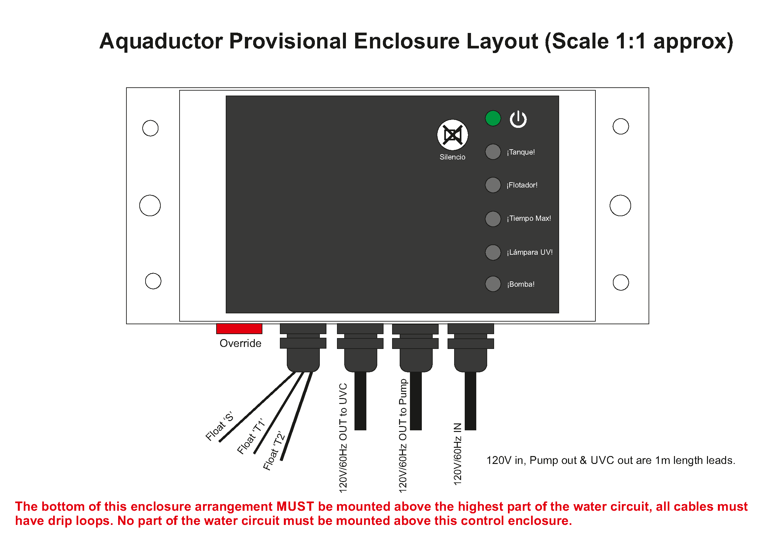

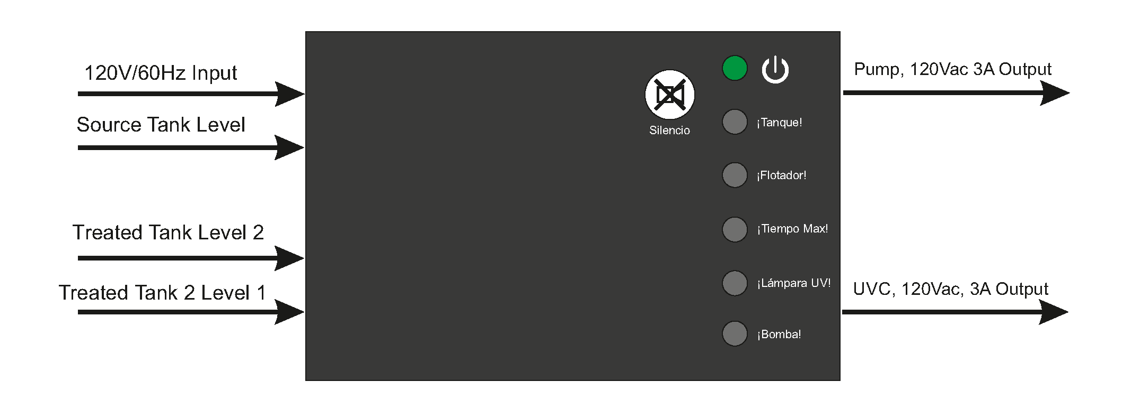

**Ensure that you install any legally mandated warning signage around the UVC Tube, so that any future maintainers will be aware that it is a UVC light emitter, and precautions can be taken.**

**IF YOU DO NOT UNDERSTAND THE ABOVE STATEMENT, PLEASE CONSULT A LOCAL EXPERT.**

You are now ready to commission your Aquaductor controller.

## Commissioning Aquaductor

With the controller turned OFF, ensure that the float switches are in the following position:

* Set **T1** to HIGH level (closed contacts).
* Set **T2** to HIGH level (closed contacts).
* Set **S** to HIGH level (closed contacts).

Turn ON the controller.

These settings should not cause the Pumping Cycle to begin (UVC Tube warmup, pumping) or any Alarms to occur. If they do, please turn the controller OFF and check & fix your Float Switch Levels, then turn the controller ON again. This condition is generally caused by a confusion over the float switches.

If any faults occur after carrying this out, note the indicator that is lit and use the troubleshooting section to determine the cause.

We are now ready to check the water purification system. Ensure that the float levels are as specified above, all HIGH.

* Begin filling the Source Tank with water. Add enough water so that the S Float Switch is set HIGH, then add further water to allow it to be processed through when testing and fill up the Treated Tank.
* Allow **T2** to be set LOW (open contacts).
* Allow **T1** to be set LOW (open contacts).
* The Controller will begin warming up the UVC tube. This will take 2 minutes.
* The Controller will begin pumping through water to the treated tank. The pumping sequence will end when T1 and then T2 has been set HIGH due to the water level rising.

If any Alarms occur, use the troubleshooting section to determine the cause. If a Pumping Cycle Timeout has occurred, this is likely due to not putting enough water in the Source Tank to fill the Treated Tank.

Your Aquaductor is now ready to operate!

## Cleaning and Maintaining Aquaductor

**IMPORTANT: DO NOT USE THIS PRODUCT AS AN ISOLATION DEVICE, TO ISOLATE PUMP, UVC TUBE OR ANY OTHER EQUIPMENT. ENSURE THAT THE PRODUCT IS ELECTRICALLY DISCONNECTED BEFORE CARRYING OUT ANY MAINTENANCE ACTIONS.**

If you need to clean the Aquaductor tanks or maintain the Pump or UVC Tube and Filter, please ensure that the controller is turned off and disconnected from mains voltage before continuing. UVC light is harmful and care must be taken whilst working with UVC emitters.

Once maintenance has been completed, the Controller can be turned on again.

# Operating Aquaductor

## System Layout

The Aquaductor Controller is designed to automatically manage the process of purifying untreated water and making it available for domestic use from a treated tank.

To achieve this goal, it continually checks the water levels in the Treated and Source Water Tanks, and automatically begins a pumping cycle when it detects that the Treated Tank is ready for refilling. The pumping cycle warms up the UVC Tube and uses a water pump to move the water through it, sanitising the liquid as it is pumped into the Treated Tank.

As an additional safety measure, Aquaductor Controller also monitors the operational status of the UVC Tube and will notify the user via an alarm sounding if a failure occurs. Additional diagnostics fault alarms are also available, such as exceeding maximum runtime (which will occur e.g. if the Water Pump fails).”



The functions of the Aquaductor Controller are defined by the following Operational Flowchart:

## Operational Flowchart

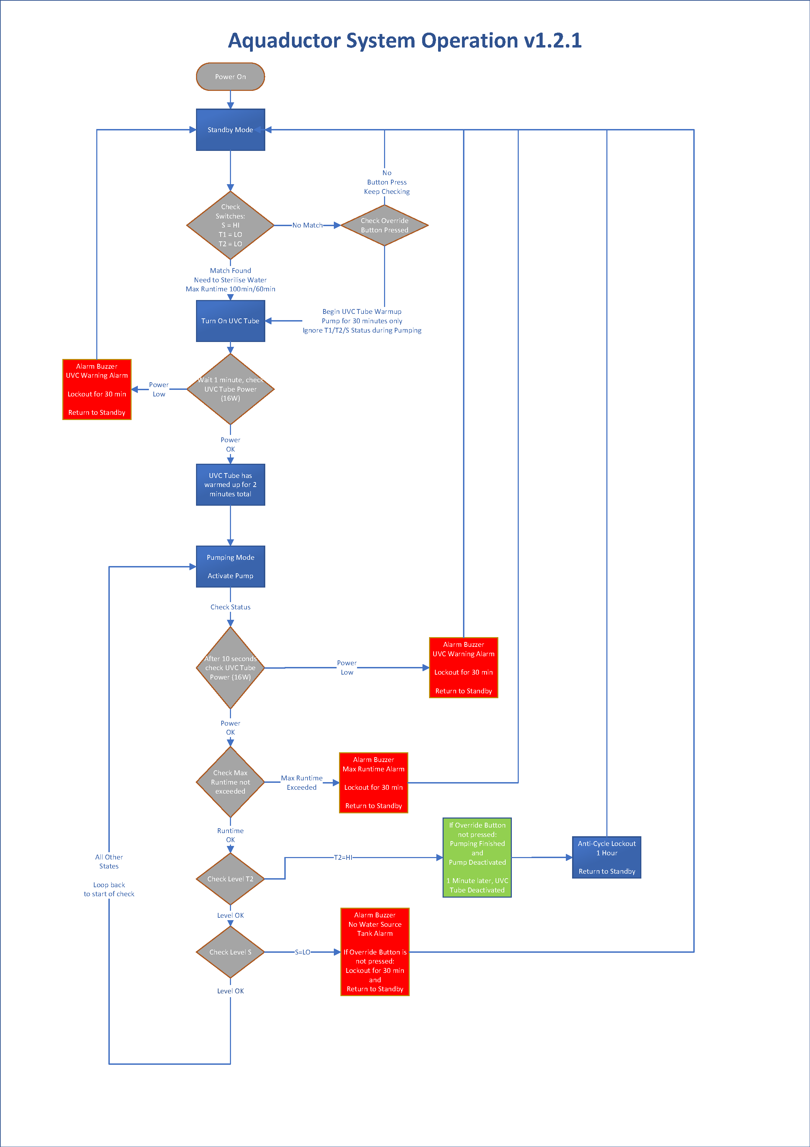

## System Operation

The Aquaductor Controller has 3 inputs from the Water Tanks:

* T2: High Float Switch on the Treated Tank (positioned at top of tank).
* T1: Low Float Switch on the Treated Tank (positioned at bottom of tank).
* S: Low Float Switch (positioned at bottom of tank).

These are used to control the following parts of the purification system:

* Water Pump, used to pump water from the Source Tank to the Treated Tank
* UVC Tube, used to sanitise water flowing from the Source Tank to the Treated Tank

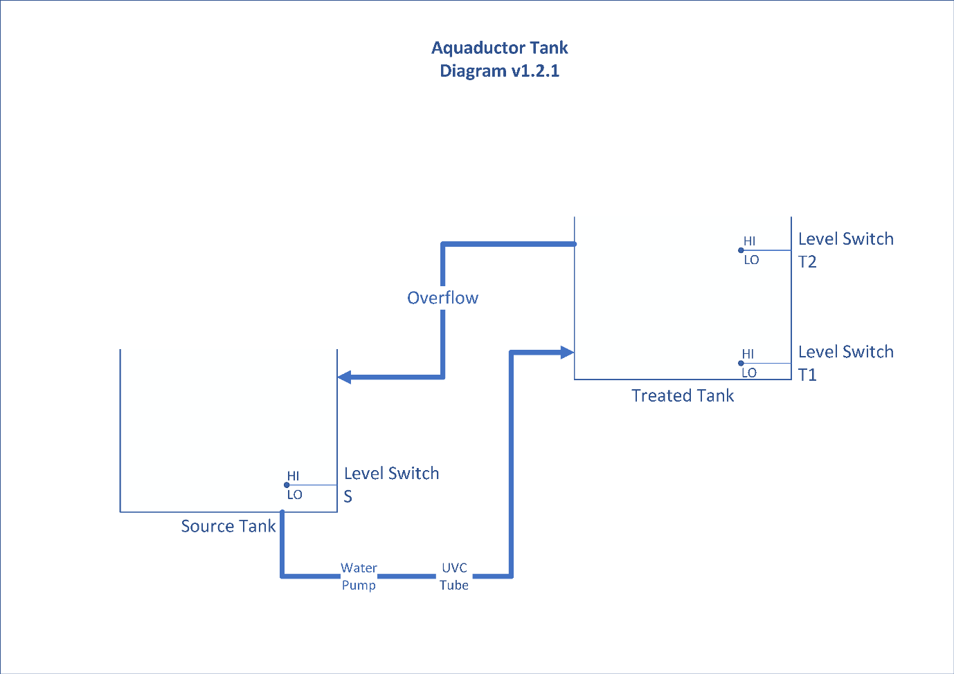



The following indicators are visible on the Aquaductor controller, from top to bottom:

* Power Indicator (Green)
* S Tank Empty Fault (Red)
* Float Switch Fault (Red)
* Maximum Runtime Exceeded Fault (Red)
* UVC Tube Fault (Red)

The System Operation flowchart outlines the operation of the Aquaductor controller. Typically, the controller will be in Standby mode – where the Treated Tank has adequate water provision, and the Source Tank is sitting ready to supply with extra water when needed. This will typically mean that T1=HI, T2=HI or LO, S=HI.

Whenever the Treated Tank requires refilling, the controller will automatically sanitise and pump additional water from the Source Tank.

This will typically be represented by the lower Float Switch in the Treated Tank, T1, transitioning from HI to LO as the amount of water in tank begins to run down.

As this happens, the controller will then move to the Pumping Cycle. To ensure that sterilisation operates correctly and safely, the UVC Tube will first be warmed up. This will take 2 minutes. 60 seconds into this warm-up period, the controller will begin checking the tube for correct current draw and will enter an alarm state if is this lower than the amount specified for the UVC Tube. The current will be continuously monitored throughout the pumping cycle.

After the UVC Tube has warmed up, the Water Pump will be turned on. The Pumping Cycle will continue until one of the following conditions is met:

1. T1 and T2 Level Switches have been set HI, showing that the Treated Tank is now full. The Pumping Cycle has successfully completed and a 1 hour lockout period will be applied for anti-cycling purposes before the controller is allowed to go back to Standby mode and check and see if a further Pumping Cycle is needed.  
   **NOTE, this means that once a pumping cycle has been successfully completed (T1 & T2 going high) the controller will not start the UVC & Pump again for 1 hour even if the floats T2 & T1 go low!**
2. Source Tank Level Switch has been set to LO, indicating that there is no more Source Water in the Tank to treat. This is treated as a fault state due to the Source Tank running out of water. This will trigger a Fault Alarm, and the Pumping Cycle will immediately end, followed by a 30 minute Fault Lockout. After this lockout period has ended, the system will return to Standby mode.
3. Maximum Runtime has elapsed since turning on the pump (this is variable depending on regional jumper setting). This is treated as a timeout fault condition, as the Pumping Cycle should complete in less than the maximum time allotted due to the relative tank sizes and pump speeds. This will trigger a Fault Alarm, and the Pumping Cycle will immediately end, followed by a 30 minute Fault Lockout. After this lockout period has ended, the system will return to Standby mode.

## System Inputs & Interrupts

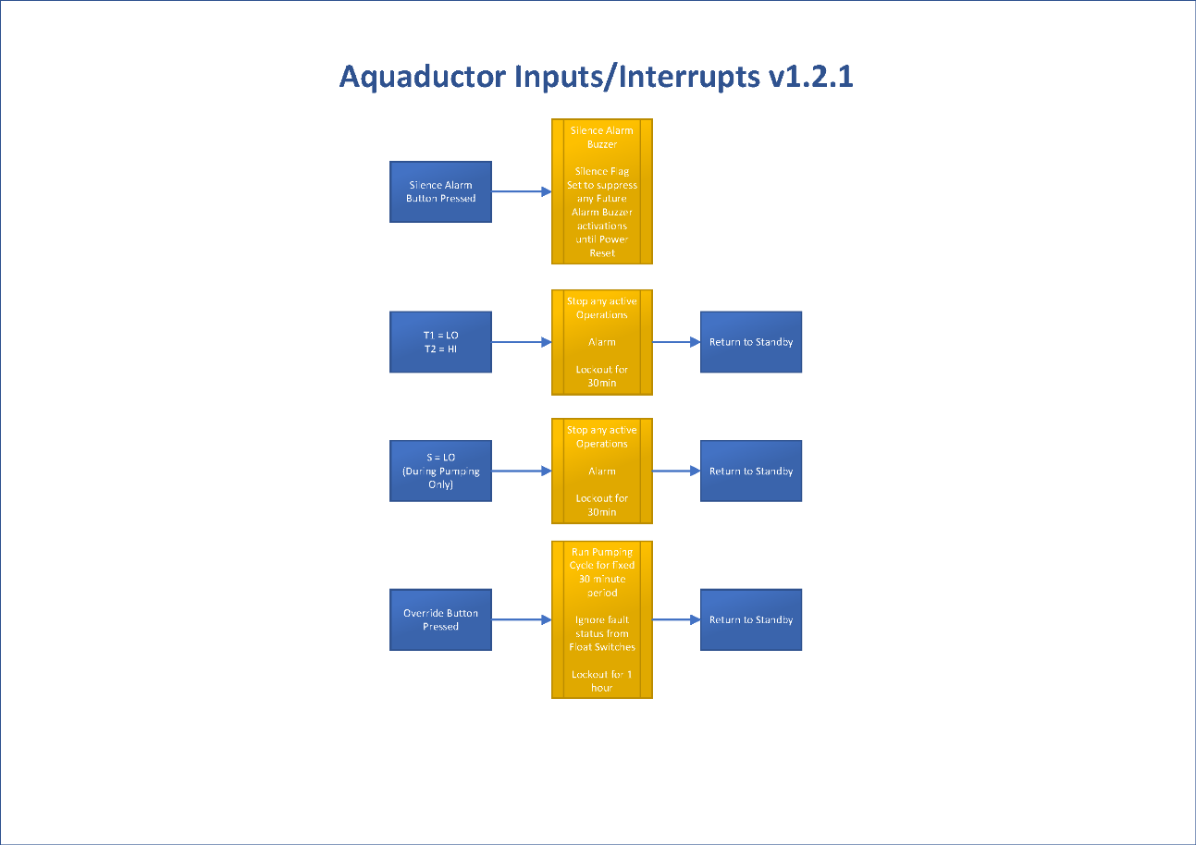

Inputs (button-presses from the user) and Interrupts due to fault conditions can happen at any time, regardless of whether the system is in Standby, Pumping Cycle or Lockout mode. The only exception to this is the Source Tank Float Switch going LOW, which is only checked during the Pumping Cycle.

1. If the Silence Alarm Button on the Controller is pressed, the system will silence the buzzer for any present alarms that may be operating. This will only affect the sounder and not change the Fault Status behaviour. Any future alarms will also not be accompanied by buzzer activation. If an alarm is not currently sounding when pressed, it will still affect any future alarms that may execute. This behaviour will continue until a power reset is carried out on the Controller by turning it off and on again.
2. If the Float Switches achieve the states below, the system will Alarm and go into Fault Lockout for 30 minutes. If a Pumping Cycle is in progress when the fault occurs, it will be aborted immediately. It should not be possible for T2 to be HI when T1 is LO – they can only both be HI when the Treated Tank is full, thus this represents a fault condition that must be investigated. This condition must be cleared before the system will be allowed to operate.
   1. T1 Float Switch = LO
   2. T2 Float Switch = HI
3. If the Float Switches achieve the state below ***during the Pumping Cycle only***, the system will Alarm and go into Fault Lockout for 30 minutes. The Pumping Cycle will be aborted immediately. This condition must be cleared before the system will be allowed to operate. No water in the Source Tank during pumping means that the normal volume of water will not be available to the user and may require corrective action.
   1. S Float Switch = LO
4. If the Override Button on the Controller is pressed, the system will automatically begin a 30 minute pumping cycle. During this cycle, the states of the Float Switches will be ignored, although UVC Tube current status will remain monitored as before. After the pumping cycle has ended, the system will lockout for 1 hour as usual, and then go back into Standby mode and await further operation. If you wish to abort the override sequence, you will have to turn off power to the controller. This sequence is designed for use when you have encountered a fault condition (e.g. on the Float Switches) and you wish to begin a pumping cycle regardless. When the override button is pressed (and the system is not in the 1 hour lockout) the UVC tube will start approximately 2 minutes before the pump starts.

## Fault Indication

When the Aquaductor system encounters a problem, it will respond by entering an alarm state, sounding a buzzer and lighting the appropriate Fault Indicator, depending on the Fault Alarm triggered. This will alternatively sound ON and OFF every second, and the Fault Indicator will remain ON.

The status of the Fault Indicator LEDs on the Controller indicate what fault has been triggered, to aid with diagnosis. The Indicator patterns are as follows:

|  |  |  |
| --- | --- | --- |
| Fault Description | Indicators | Buzzer |
| No Fault | As normal; all Fault Indicators unlit | No |
| UVC Tube Fault | UVC Tube Fault lit | Yes |
| Water Pump Fault | If the pump is faulty, the controller may alarm due to maximum runtime being exceeded, causing the Maximum Runtime Fault to light. | Yes |
| Maximum Runtime Exceeded | Maximum Runtime Fault lit | Yes |
| Float Switches Fault | Float Switch Fault lit, only fault detected is the T1 showing high level, while T2 shows low level. | Yes |
| Source Tank Empty Fault | Source Tank Empty Fault lit | Yes |

UVC Tube and Maximum Runtime Exceeded Faults will be reset only by power cycling the Controller, that is, by turning it off and on. Float Switch faults will reset at the start of every pumping cycle to see if the condition has cleared, and Source Tank Empty faults will reset as soon as the Source Tank is no longer empty.

Pressing the Silence Alarm button will silence the buzzer for any active faults, and any future ones that are found. It will not reset the fault indicators.

NOTE, when water is demanded by the floats T1 & T2 being low (and the float S being high), the UVC tube will start approximately 2 minutes before the pump starts.

To reset the system, simply disconnect it from the 120Vac supply.

**Mounting the controller**

Find a suitable place to mount the controller, above any sources of water, make sure all the leads can reach their intended connections. Then mount the Controller. Connection order is:

1, Connect the Controller to the three float outputs, S, T1 & T2. 2, Connect the Controller to the UVC tube. 3, Connect the Controller to the pump.  
 **Quick test 1:-**Set all 3 floats to the high (closed) position.  
Turn on the Controller, it will beep, flash the LEDs and wait for float changes.  
Move the float T2 to the low, open position, nothing will happen.  
Keeping the float T2 in the low, open position, now move float T1 to the low, open position.  
The controller will start the UVC tube and after 2 minutes the pump will start.  
Leave the pump running for 2 minutes.  
Move the float T1 to high, nothing will happen. Move T2 to high, the pump will stop and a minute later the UVC tube will stop.  
**THIS IS CORRECT OPERATION**.

**Quick test 2:-**Set all 3 floats to the high (closed) position.  
Turn on the controller, it will beep, flash the LEDs and wait for float changes.  
Move the float T1 to the low, open position, the system will alarm on Flotador error.  
**THIS IS CORRECT OPERATION.**

**Quick test 3:-**  
Set all 3 floats to the high (closed) position.  
Turn on the controller, it will beep, flash the LEDs and wait for float changes.  
Move the float S to the low, open position, nothing will happen  
Move the float T2 to the low, open position, nothing will happen  
Keeping the floats S & T2 in the low, open position, now move float T1 to the low, open position.  
The system will alarm on a Tanque error after 2 minutes, after UVC Tube warmup is completed.  
**THIS IS CORRECT OPERATION.**

**Quick test 4:-**Set all 3 floats to the high (closed) position.  
Turn on the controller, it will beep, flash the LEDs and wait for float changes.  
Move the float T2 to the low, open position, nothing will happen  
Keeping the float T2 in the low, open position, now move float T1 to the low, open position.  
The controller will start the UVC tube and after 2 minutes the pump will start.  
Remove the UVC tube connector from the controller.  
The controller will stop the pump and alarm on a UVC error.  
**THIS IS CORRECT OPERATION**.

# Troubleshooting

* Aquaductor Controller is beeping
  + It is alarming because it has encountered a fault condition. Please refer to the Fault Indication section to diagnose the fault.
* Turning the Controller On/Off
  + Normally the Aquaductor Controller will turn on as soon as you connect the mains electrical supply. To turn off Aquaductor, please disconnect the external power supply from the main electrical supply. There is no dedicated on/off switch for the Handheld.
* Controller does not turn on
  + Please ensure that the wired power inlet cable is connected securely.
  + Using an **RCD/GFCI/RCBO device,** please ensure that it is activated and not in TEST mode. It will not provide power in this state.
  + Please check that the internal fuses have not blown. Ensure that the system is disconnected from mains electricity whilst removing or replacing the fuses.
* Controller taking a long time to fill Treated Tank
  + Ensure that the Water Pump is operating correctly, and that any inline filters are not clogged. It may also be necessary to confirm correct operation of the float switches for each of the tanks.
* Fault Indicators
  + Please see the Fault Indication section for full information and diagnosis.
  + Please note any information and communicate it to Support if necessary.
* UVC Tube does not operate
  + Check to see if the UVC Tube is connected properly to the Controller and power is provided.
  + The UVC Tube may need replacement – confirm that the new UVC Tube operates correctly afterwards.
* Pump does not operate
  + Ensure that the Water Pump is operating correctly, and that any inline filters are not clogged.
  + Ensure that there is water present in the Source Tank, and that there are no inline valves closed to prevent water flow.
* Power Loss to Controller during Pumping Cycle
  + After power loss, the Pumping Cycle will immediately abort.
  + Once power is restored to the Controller, it will go into Standby mode as usual and begin another Pumping Cycle if needed.
* Controller continually resets itself
  + Ensure that the power lead is firmly plugged in.
  + If you are having regular power fluctuations at your premises, this may be causing resets due to low supply voltage. Please contact your electricity company to report the fault.
  + Check to see if the reset occurs at particular times, e.g. when the UVC Tube turns on/off, or the Water Pump on/off, or something else.
  + If the problem persists, please note any information and communicate it to Support if necessary.

# Warranty

All Aquaductor products carry a 1 year back to base warranty covering manufacturing defects and component failures. The product has no user-serviceable parts except where otherwise stated, and must never be opened or disassembled, and as such should only be repaired by skilled and authorised personnel. Failure to comply could result in unsafe operation and should not be attempted under any circumstances. Contact below for a list of approved service agents. Note: Any unauthorised repair or adjustment will automatically render the warranty invalid.

# Maintenance

Prior to installation and any maintenance of the unit, check the casing for signs of damage or misuse. Check the leads for signs of damage, ensure the outer insulation is not broken. If the unit is damaged it must NOT be used and should be returned to the supplier. The unit must not be used for any purpose than for that recommended by the manufacturer. The unit must not be submerged or exposed to liquid.

Please remember to follow the **Cleaning and Maintaining Aquaductor** instructions regularly to ensure good maintenance on the UVC Tube and filtration system.

# Returning Aquaductor Controller for repair

If returning a product to the manufacturer for repair, it should be sent freight pre-paid to the appropriate address. A copy of the Invoice and of the packing note should be sent simultaneously by airmail to expedite clearance through Customs, if relevant. A repair estimate showing freight return and other charges will be submitted to the sender, if required and applicable, before work on the device commences.

Manufacturer Address for Repair and Spare Parts:

**Acksen Ltd**  
www.acksen.com - United Kingdom. Or an approved (approved by us) repair company.

# WEEE Regulations

For EU customers Aquaductor offer a product take-back service. For customers within the European Union (only) and products manufactured or sold by us; when those products reach the end of their life, simply send them back to us at your expense, we will dispose of them according to the relevant legislation. WEEE Registration Number WEE/DD2117VU.